Streamlining Ticket Assignment for

Efficient Support Operations

# Introduction

* + Project Title: Streamlining Ticket Assignment for Efficient Support Operations
  + Team Members: 1. Yerriboina Sri Bhargav(Leader)

1. Kappaguntula P V L G Saraswathi
2. Kondamuri Pavan Kumar
3. Nagesh Terlapu

# Project Overview

* Purpose: This project focuses on automating ticket assignment in ServiceNow to eliminate manual routing, reduce human error, and improve service efficiency.
* Features: Automated routing, ACL-based security, user/group management, custom tables, and flow-based logic.

# Architecture

* Platform: ServiceNow cloud platform
* Components: Users, Roles, Groups, Tables, Flows, ACLs

# Implementation Steps

* 1. **Create Users**
     + • Open ServiceNow.
     + • Click on All >> search for Users.
     + • Select Users under System Security.
     + • Click on New.
     + • Fill in the user details (User ID, Name, Email, etc.).
     + • Click Submit.
     + • Repeat to create additional users
  2. **Create Groups**
     + • Navigate to All >> Groups.
     + • Click New to create a new group.
     + • Provide group name and description.
     + • Click Submit.
  3. **Assign Roles**
     + • Navigate to Users or Groups.
     + • Open a record and scroll to Roles tab.
     + • Click Edit, select roles to assign (e.g., admin, itil).
     + • Click Save.
  4. **Create Tables**
     + • Navigate to Tables under System Definition.
     + • Click New to define a custom table (e.g., Operations Related).
     + • Set fields and properties.
     + • Click Submit.
  5. **Assign Users to Groups**
     + • Open a group record.
     + • Scroll to Users related list and click Edit.
     + • Add users and click Save.
  6. **Assign Roles to Tables**
     + • Open table settings.
     + • Use Access Control or directly assign roles in table permissions.
  7. **Create Access Control Rules (ACLs)**
     + • Navigate to System Security >> Access Control (ACL).
     + • Click New to define a rule for the table or field.
     + • Specify conditions and required roles.
     + • Click Submit.
  8. **Create Flow for Ticket Routing**
     + • Open Flow Designer.
     + • Create a new flow triggered on ticket creation.
     + • Add logic to assign tickets based on category or user input.
     + • Activate the flow.

# Conclusion

The implementation of the automated ticket routing system at ABC Corporation has been a significant success. By leveraging the capabilities of ServiceNow, we have streamlined the process of assigning support tickets to the appropriate teams, addressing the challenges of manual routing, and ensuring timely resolution of issues.

* 1. **Create Users**

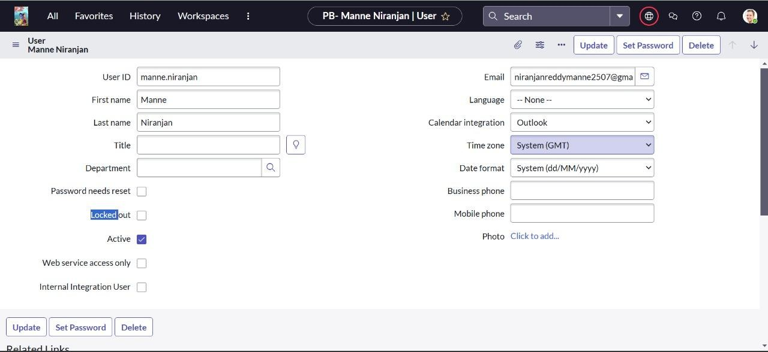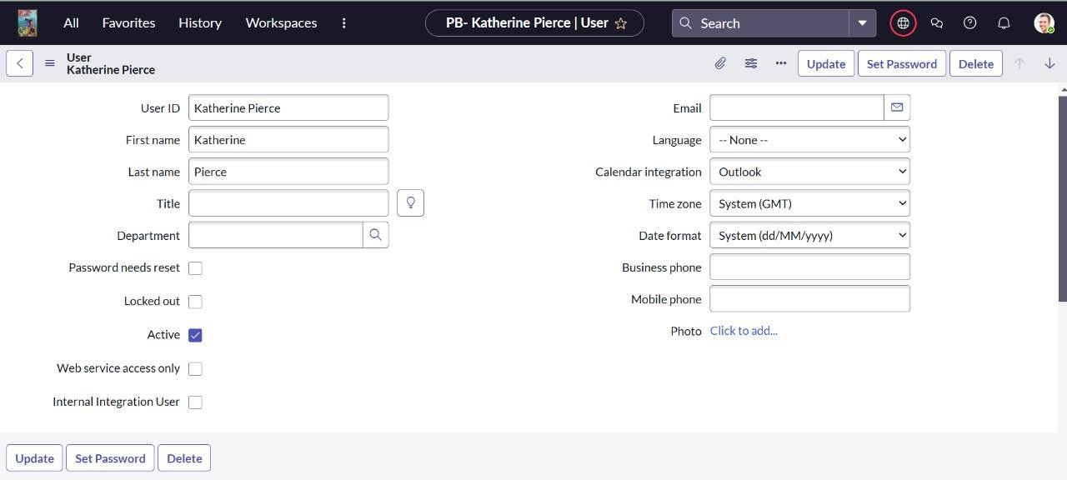

* 1. **Create Groups**

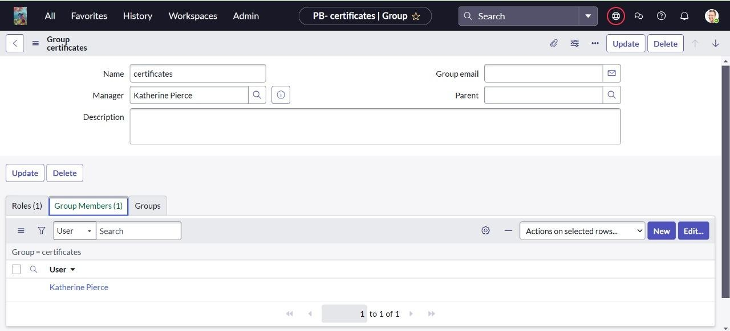

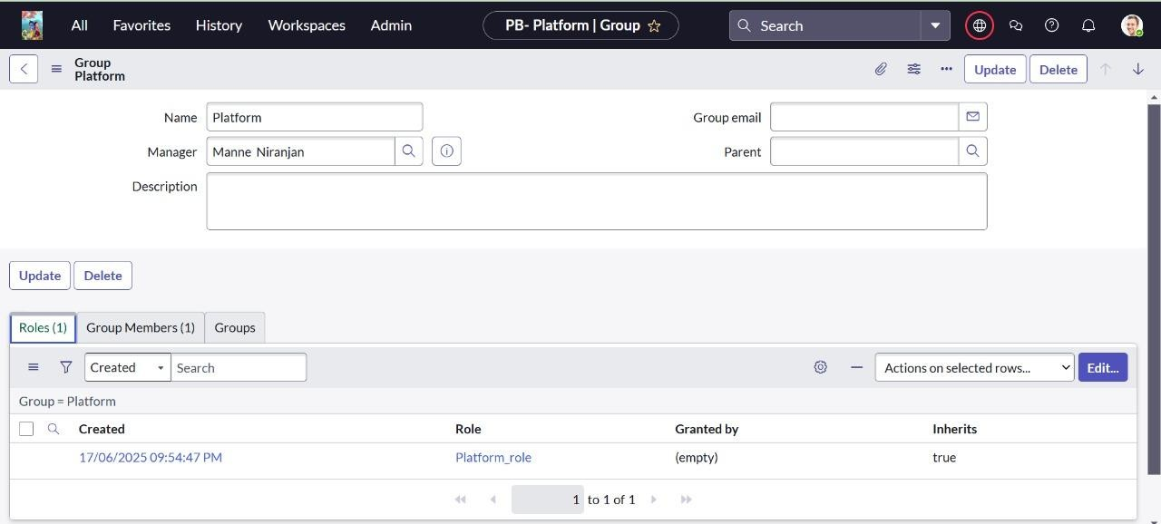

* 1. **Assign Roles**

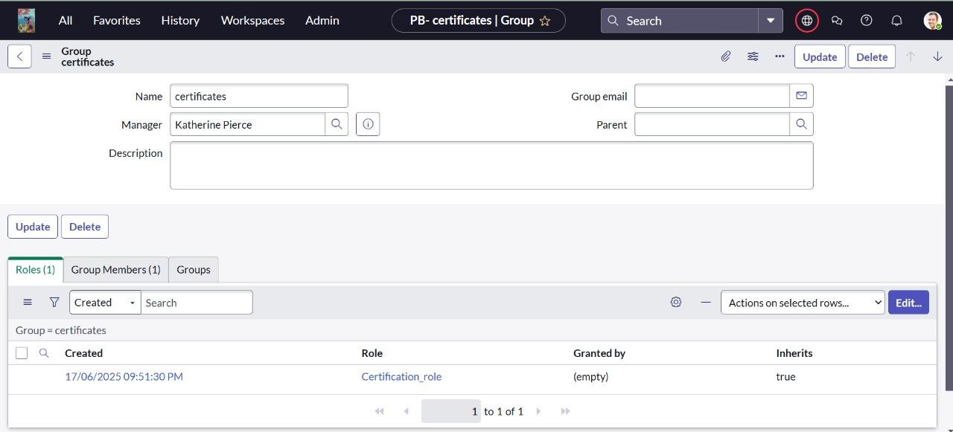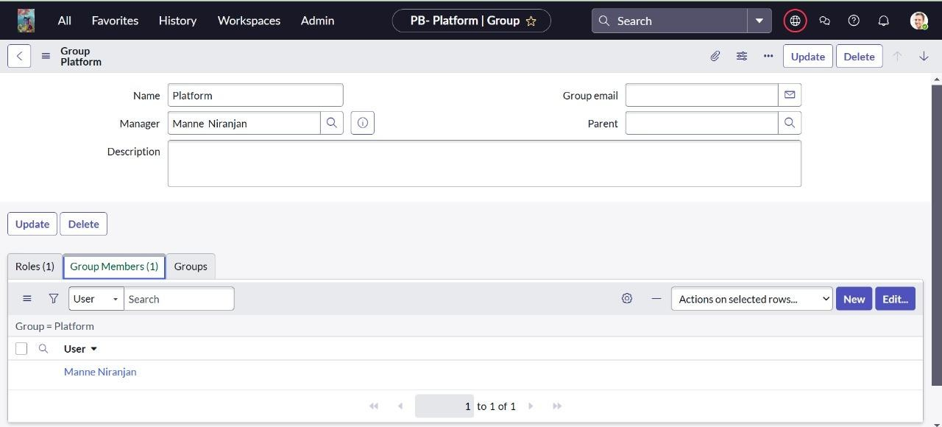

* 1. **Create Tables**

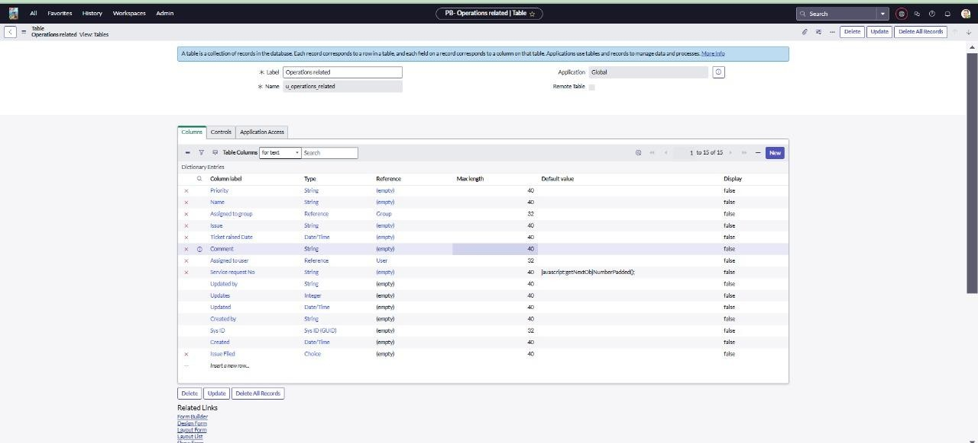

* 1. **Create Access Control Rules (ACLs)**

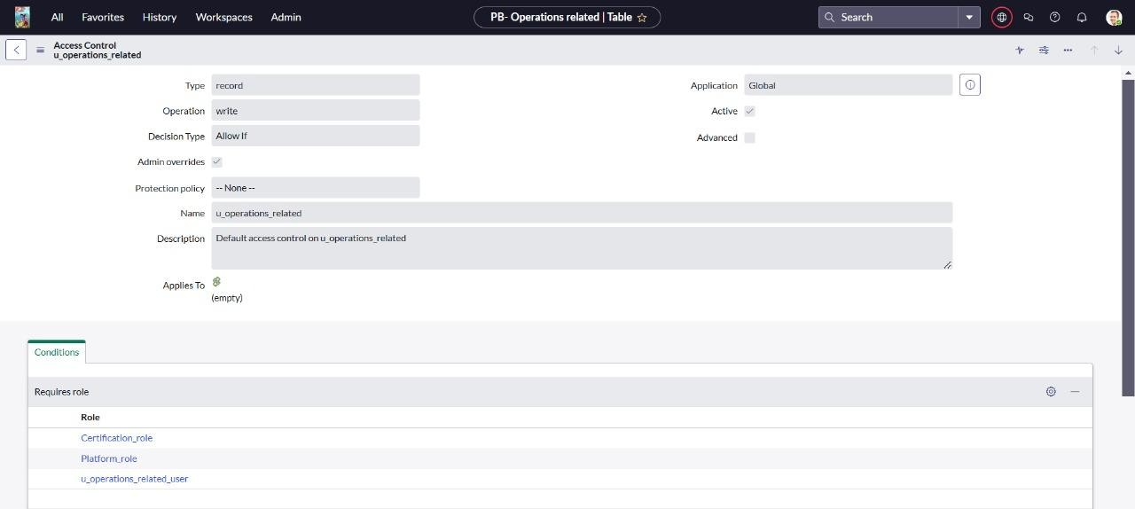

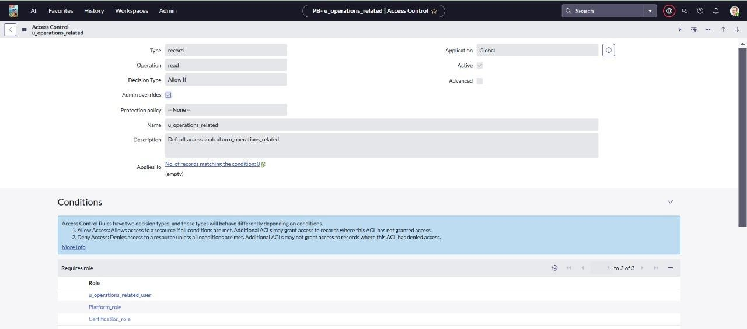

**4.8 Create Flow for Ticket Routing**

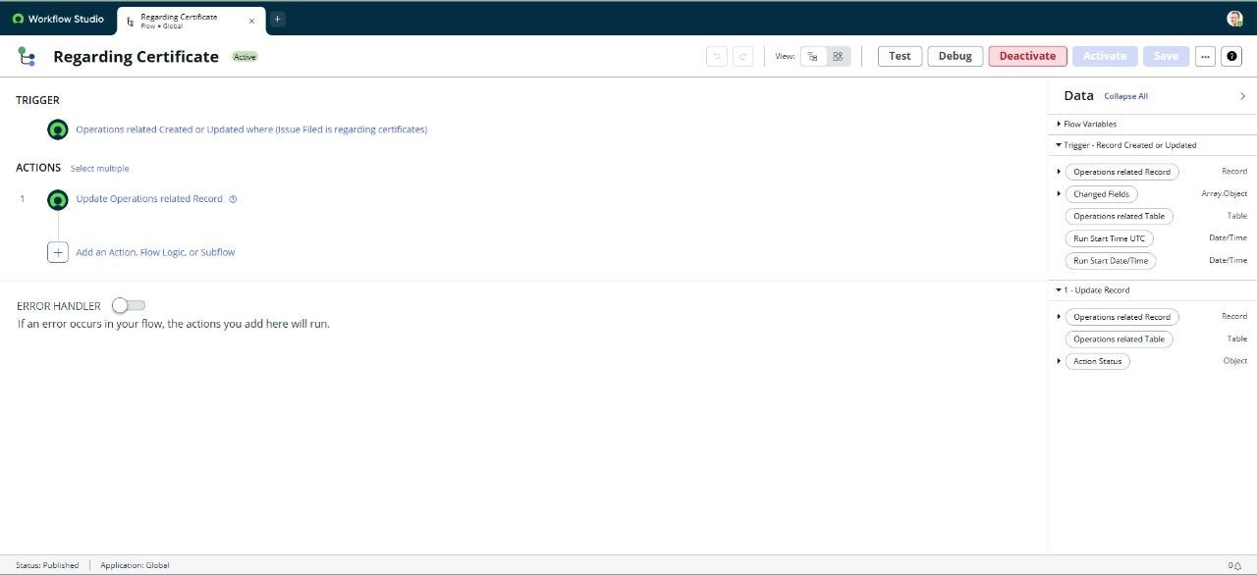

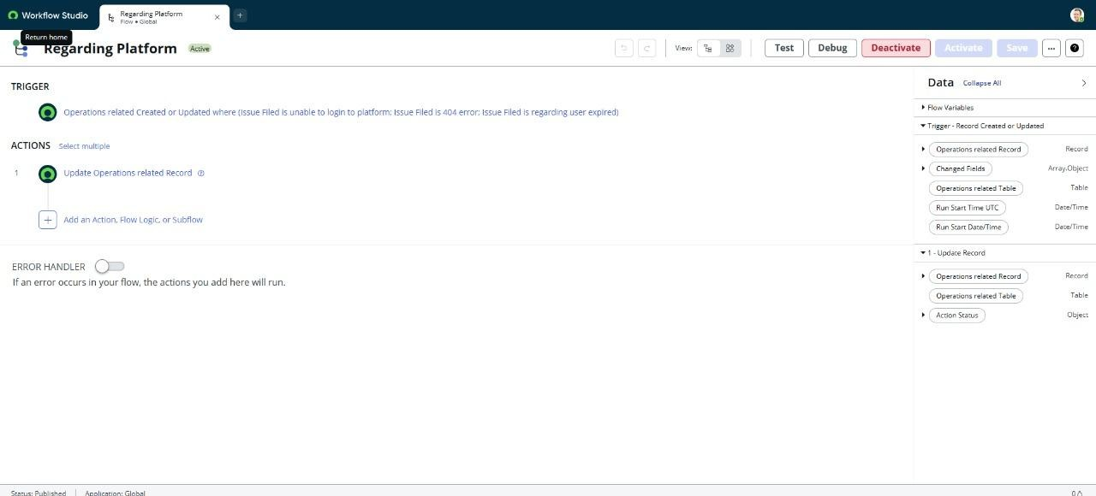

-------------------------------------------- THE END ------------------------------------------------------------